* Task 1: The table below shows water use for different purposes in four countries. The use of water by four different countries (%)

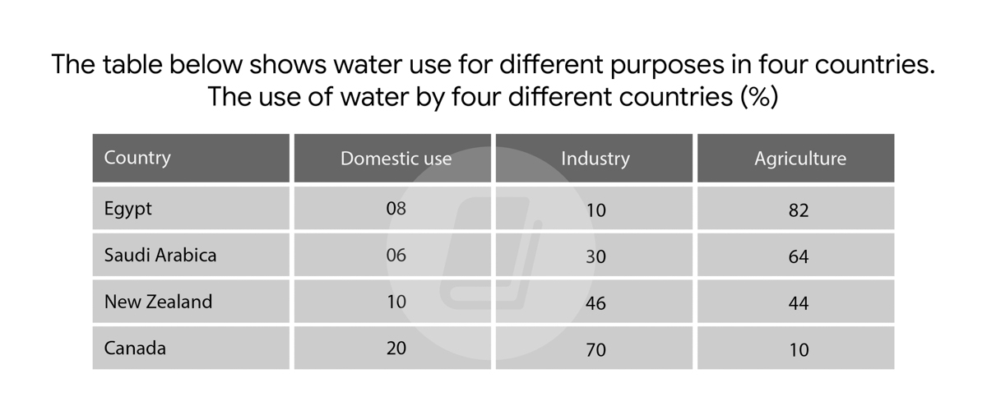

* Task 2: If old people are no **longer physically, mentally or financially able** to look after themselves, younger family members should be legally responsible for supporting them. To what extent do you agree or disagree?

|  |  |
| --- | --- |
|  |  |
|  |  |

Many people think that junior family members should be legally responsible for senior family members when they become physically, mentally and financially unable to take care of themselves. In my opinion, I completely disagree with the above statement and there are many reasons to support my point of view which I shall explain my perspective in detail in the following paragraphs.

To begin with, there are several reasons why younger people taking care of elderly people should not be put into law. Firstly, there are a lot of low-income households that need to take care for themshelves and raise their children. Therefore, they may not have enough money to look after their parents so the governments need to help the old people. To illustrate, they should build a facility for disabled people and some nursing houses, they can build a community where old people can make friends and talk with each other, it can help them relax and the elderly people would be in the safe place. Moreover, in this modern day, most young people work in business so they may not have enough time to look after their old parents. Hence, younger people should not be legally responsible for older family members.

On the other hand, every young generation must be responsible for their elder individuals, because they are parents of them. Additionally, as humans become old they feel want to close their children so the government should give an amount of money for these families.

In conclusion, although each side has its pros and cons, in my opinion, I think that peoples should be given the chance to look after themselves and their children, not their parents.